GOVERNMENT COLLEGE OF ENGINEERING, JALGAON
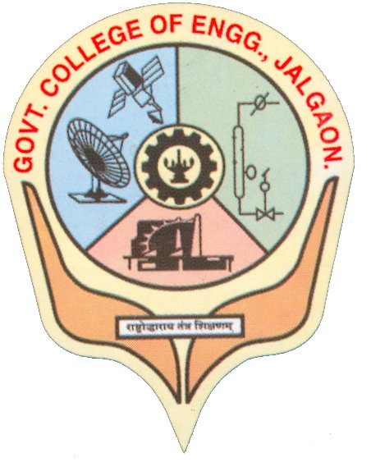
(An autonomous Institute of Government of Maharashtra)
National Highway No-06, Jalgaon- 425002.
Phone No. 0257 – 2281522 Fax.No. 0257 – 2281319
Website : www.gcoej.ac.in E-mail - principal.gcoejalgaon@dtemaharashtra.gov.in

Academic Calendar for the Year 2022 – 2023
III and iV year B. Tech. (2022 – 23) (Revised as on 13 April, 2023)
Activity | Date / Date-Slots | Responsibility
Commencement of odd semester (Semesters V, VII) | Final Year - August 01, 2022  Third Year - August 08, 2022 | Dean Academics
Mid Semester Examination (MSE) based on 50 % syllabus. | October 15 - 21, 2022 | HoD and Course Coordinator
Submission of term work of all courses (Winter 2022) | December 17, 2022 | Course Teacher and Coordinator
Meeting of all faculty members regarding finalizing list of Not Eligible (NE) Students due to lack of attendance (department-wise) | December 19, 2022 | HoD
Repeat Mid-Semester Examination (for odd semester courses) | December 22 - 29, 2022 | HoD and Course Coordinator
End of odd semester (Semesters V, VII) | December 20, 2022 | HoD
ESE laboratory exam (Winter 2022)* | January 2 - 9, 2023 | HoD and CoE
ESE theory exam (Winter 2022)* | January 11 - 21, 2023 | CoE
ESE theory exam (Re-exam Winter 2022)* | February 16 - 25, 2023 | CoE
ESE laboratory exam (Re-exam Winter 2022)* | February 27 - March 4, 2023 | HoD and CoE
Commencement of even semester (Semesters VI, VIII) | January 30, 2023 | Dean Academics
MSE based on 50 % syllabus. | March 23 - 31, 2023 | HoD and Course Coordinator
Submission of term work of all courses (Summer 2023) | May 18, 2023 | Course Teacher and Coordinator
Meeting of all faculty members regarding finalizing list of Not Eligible (NE) Students due to lack of attendance (department-wise) | May 19, 2023 | HoD
Repeat Mid-Semester Examination for even semester courses | May 20 - 26, 2023 | HoD and Course Coordinator
End of even semester (Semesters VI, VIII) | May 26, 2023 | HoD
ESE laboratory exam (Summer 2023) # | May 29 - June 03, 2023 | HoD and CoE
ESE theory exam (Summer 2023)# | June 05 - 17, 2023 | CoE
ESE theory exam (Re-exam Summer 2023)# | July 10 - 18, 2023 | CoE
ESE laboratory exam (Re-exam Summer 2023)# | July 20 - 26, 2023 | HoD and CoE
Commencement of next academic year 2023-24 | August 1, 2023 | Dean Academics

Important Points to be noted:
- Students should note that it is mandatory to earn the audit points by participating / performing in co-curricular and extra-curricular activities. Total number of audit points required throughout the B. Tech. program is 8 each for co-curricular and extra-curricular activities. For Direct Second Year admitted students, this requirement is 6 each for co-curricular and extra-curricular activities.
- Internships / Training Programs are required to be completed by the students during vacation periods between III to VIII semester and will be assessed in semester VIII. Students should refer the curriculum structure and syllabus for more details.

MSE –> Mid-Semester Examination
ESE –> End Semester Examination
* indicates ESE for all courses of odd semester only
# indicates ESE for all courses of even semester only

Revision Date: 13.04.2023

(Dr. S.T. Vagge)  Dean - Academics | (Dr. G. M. Malwatkar)  Principal

Copy to:
1. Institute Website
2. AEC Notice Board
3. All HoDs, Deans, CoE, Asst. CoEs for necessary action and to display on notice board

